SOFTWARE REQUIREMENTS SPECIFICATION

**For**

**Online Quiz System**

**Prepared by:-**

*Aswath C M*

*Ajay Prakash B*

*Deva Darshan*

*Bharanidharan M*

# Introduction

## Purpose

The main objective of this document is to illustrate the requirements of the project Online quiz system. The document gives the detailed description of the both functional and non-functional requirements. This project aims to provide a comprehensive platform for educators to create and conduct quizzes. Teachers can generate unique codes for custom or predefined quizzes, initiate sessions, and monitor real-time statistics. Students access quizzes via codes, submit answers, and view post-quiz accuracy. This system enhances interactive learning by facilitating efficient quiz management. This project describes the hardware and software interface requirements using ER diagrams and UML diagrams.

## Document Conventions

* + - Entire document should be justified.
    - Convention for Main title

Font face: Times New Roman Font style: Bold

Font Size: 14

* + - Convention for Sub title

Font face: Times New Roman Font style: Bold

Font Size: 12

* + - Convention for body

Font face: Times New Roman Font Size: 12

## Scope of Development Project

The Online Quiz System is a comprehensive platform designed to streamline quiz management for educators and enhance the learning experience for students. The project encompasses the creation, administration, and participation in quizzes, catering to the dynamic needs of both teachers and students.

For teachers, the system allows quiz creation with diverse question types such as dropdowns, fill-ups, and checkboxes. Additionally, teachers can access predefined quizzes, each associated with a unique code. The platform facilitates real-time monitoring during quiz sessions, presenting live statistics and accuracy updates upon submission. Students can seamlessly participate in quizzes by selecting predefined mock quizzes or entering unique codes provided by teachers. Upon completion, students receive instant feedback on their accuracy, promoting a responsive and engaging learning environment.

The project's scope extends to the development of a user-friendly interface, efficient code generation, and secure storage of quiz data. By addressing the limitations of traditional quiz methods, the system aims to optimize the educational process and foster interactive and effective learning experiences for both educators and students.

.

## Definitions, Acronyms and Abbreviations

JAVA -> platform independence SQL-> Structured query Language ER-> Entity Relationship

UML -> Unified Modeling Language

IDE-> Integrated Development Environment SRS-> Software Requirement Specification

## References

* + - Books

 Software Requirements and Specifications: A Lexicon of Practice, Principles and Prejudices (ACM Press) by Michael Jackson

Software Requirements (Microsoft) Second EditionBy Karl E. Wiegers

Software Engineering: A Practitioner’s Approach Fifth Edition By Roger S. Pressman

* + - Websites

[**http://www.slideshare.net/**](http://www.slideshare.net/)

[**http://ebookily.net/doc/srs-library-management-system**](http://ebookily.net/doc/srs-library-management-system)

# Overall Descriptions

## Product Perspective

Use Case Diagram of Online Quiz System

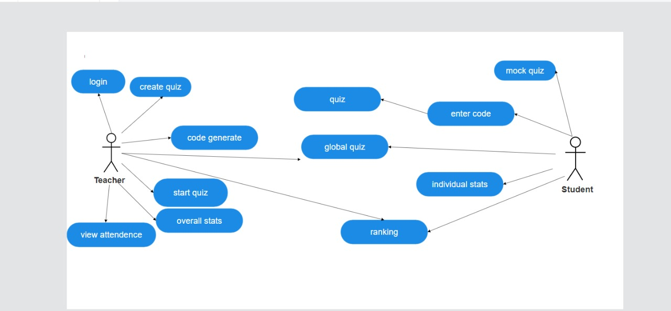

The use case diagram outlines the interactions between system actors (Teachers and Students) and their respective functionalities within the Online Quiz System. Use cases include creating quizzes, accessing predefined quizzes, generating quiz codes, starting quizzes, and viewing statistics. This visual representation aids in understanding user-system interactions, guiding the design and development of a streamlined and intuitive quiz management system.

## Product Function

Entity Relationship Diagram of Online Quiz System

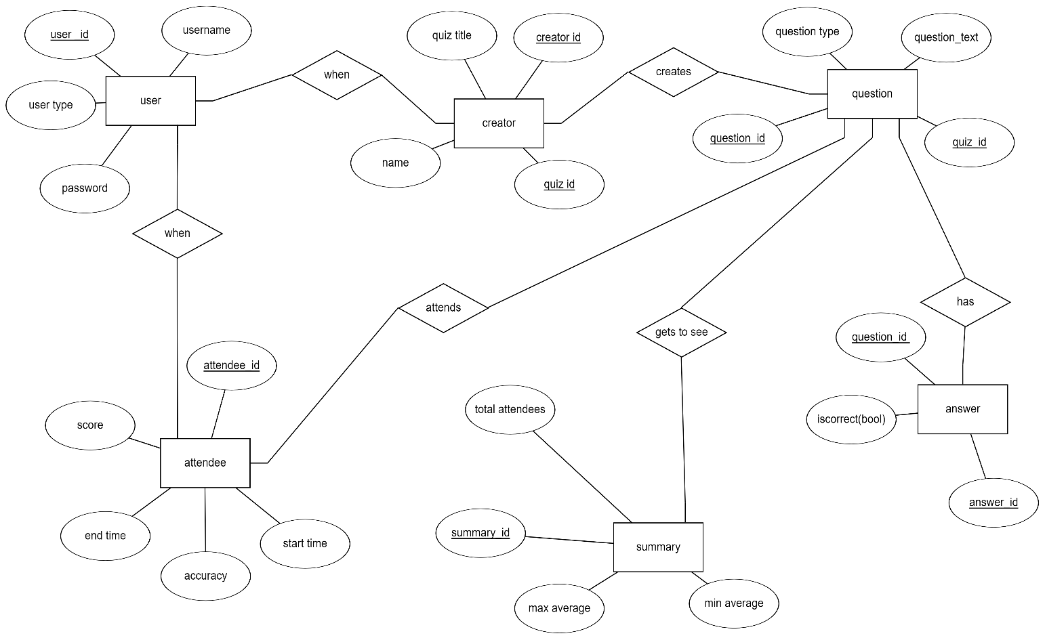

The Entity-Relationship (ER) diagram illustrates the fundamental structure of the Online Quiz System. Entities such as Users, Quizzes, Questions, Answers, QuizAttendees, and QuizSummary are interconnected to capture the relationships and dependencies within the system. The QuizAttendees entity tracks student participation and performance, while QuizSummary consolidates statistics for each quiz. Attributes like UserID, QuizID, QuestionID, AnswerID, and relevant timestamps ensure data integrity. This ER diagram forms the foundation for database design, representing a clear and concise model of the system's data structure.

## User Classes and Characteristics

The Online Quiz System caters to two primary user classes: Teachers (Quiz Creators) and Students (Quiz Attendees).

Role: Quiz Creators or Teachers:

Characteristics: Domain experts with the authority to create, manage, and administer quizzes. They have the following features:

* + - Create a new quiz with various question types.
    - Access predefined quizzes.
    - Generate unique codes for quizzes.
    - Initiate and monitor quiz sessions.
    - Review real-time statistics of attendees.
    - Receive accuracy updates only upon attendees' quiz submission.

Role: Quiz Attendees or Students:

Characteristics End-users engaging in quizzes with the following features: They have the following features:

* + - Select mock quizzes or enter codes to attend specific quizzes.
    - Take quizzes and submit answers.
    - Receive instant feedback on accuracy.
    - View stats post-quiz completion.

## Operating Environment

## The Online Quiz System operates within a web-based environment, accessible through standard internet browsers. It is designed to be platform-independent, ensuring compatibility with various devices, including laptops, tablets, and smartphones. The system relies on a secure and stable internet connection to facilitate seamless interactions between users and the quiz platform

## Assumptions and Dependencies

The assumptions are:-

* + - Users have consistent internet access for seamless quiz participation.
    - Participants are familiar with standard web browsers.
    - The system is compatible with laptops, tablets, and smartphones.
    - Users maintain the confidentiality of login credentials.
    - Quiz data accuracy depends on truthful participant responses.
    - The system assumes a reasonable number of concurrent users.
    - Users adhere to institutional policies.
    - Users stay informed about system updates.

The dependencies are:-

* + - Relies on a secure server for data storage and real-time interactions
    - Depends on a reliable database connection.
    - User access depends on valid login credentials.
    - Relies on contemporary web technologies.
    - Dependency on established security measures.
    - Depends on routine maintenance for optimal performance.

## Requirement

Software Configuration:-

Operating System: Windows, macOS, Linux.

Java Development Kit (JDK): JDK 8 or later for JavaFX development.

Integrated Development Environment (IDE): Eclipse, IntelliJ IDEA, or NetBeans for JavaFX development.

JavaFX Library: JavaFX SDK for building the graphical user interface.

Database Management System: MySQL or any RDBMS for data storage.

Web Browsers: Compatible with major browsers for end-user access.

Internet Connection: Stable connection for development and end-user access.

Hardware Configuration:-

Processor: Pentium(R)Dual-core CPU Hard Disk: 40GB

RAM: 256 MB or more

Internet Connectivity: Minimum 5 Mbps speed.

## Data Requirement

In the Online Quiz System, inputs consist of user-generated queries such as creating an account, selecting quizzes, and submitting quiz answers. The system processes these queries to provide outputs, including quiz results, attendance details, and statistics. Users can request details of their accounts, receiving output in the form of timestamps, quiz history, and accuracy statistics. The data requirements encompass user account details, quiz information, question responses, attendance records, and user preferences, facilitating effective interactions and personalized feedback within the platform.

# External Interface Requirement

## GUI

## Intuitive Quiz Creation: Teachers can effortlessly create quizzes with diverse question types, ensuring an engaging and customized quiz experience.

## Real-Time Monitoring: Teachers have access to live statistics during quiz sessions, allowing instant insights into attendee performance.

## User-Friendly Participation: Students benefit from a user-friendly interface, enabling seamless quiz participation, answer submission, and instant feedback on accuracy.

**1. Login Screen:**

- The system presents a secure login interface with fields for username and password.

**2. Dashboard:**

- Upon login, users encounter an intuitive dashboard displaying options like creating quizzes, accessing predefined quizzes, and viewing quiz statistics.

**3. Quiz Creation Interface:**

- Teachers experience a user-friendly interface for creating quizzes, specifying question types, and generating unique codes.

**4. Code Generation Screen:**

- A dedicated screen allows teachers to generate unique codes for quizzes, facilitating secure quiz access.

**5. Quiz Selection Screen:**

- Teachers and students encounter a screen for selecting quizzes, with options to choose between custom and predefined quizzes.

**6. Quiz Session Monitoring:**

- Teachers access a real-time monitoring interface during quiz sessions, providing live statistics and accuracy updates.

**7. Quiz Participation Interface:**

- Students interact with a straightforward interface for participating in quizzes, submitting answers, and receiving instant feedback.

**8. Results Display Screen:**

- Post-quiz completion, students view their accuracy and statistics on a clear results display screen.

**9. User Account Interface:**

- Both teachers and students have access to a user account interface to manage personal details, preferences, and view quiz history.

**10. Navigation and Responsiveness:**

- The entire GUI ensures smooth navigation, responsiveness across devices, and adherence to accessibility standards for an inclusive user experience.

# System Features

* Comprehensive Quiz Management: The system empowers teachers to create, customize, and administer quizzes with various question types, fostering a dynamic and interactive learning environment.
* Seamless User Experience: Students experience a seamless and user-friendly interface for accessing quizzes, submitting answers, and receiving instant feedback, enhancing the overall learning experience.
* Teachers can monitor quiz sessions in real-time, gaining immediate insights into attendee engagement and performance, facilitating effective post-quiz analysis.

# Other Non-functional Requirements

## Performance Requirement

The system is designed to handle simultaneous quiz sessions with a large number of attendees, ensuring smooth and responsive interactions.

* + - Response times for user interactions, such as submitting answers and viewing statistics, should be within 2 seconds under normal system load
    - Additionally, the system should support at least 100 concurrent quiz sessions without degradation in performance.

## Safety Requirement

The database may get crashed at any certain time due to Regular security audits and updates will be conducted to identify and address potential vulnerabilities. In the event of unexpected system disruptions, automated backups will be in place to prevent data loss and facilitate prompt recovery.

## Security Requirement

* + - Role-based access controls ensure that users have appropriate privileges, maintaining data integrity.
    - Encrypted credentials are required for secure access, preventing unauthorized entry.
    - System will have different types of users and every user has access constraints
    - Robust logging mechanisms are in place to record system activities, enabling effective monitoring and auditing.

## Requirement attributes

* + - The platform must be scalable to accommodate a growing user base and increased quiz sessions.
    - The system should ensure a 99.9% uptime to guarantee uninterrupted access for users.
    - The system should allow for seamless updates and maintenance without disrupting ongoing quiz activities.
    - Response times for critical actions, such as submitting answers, should not exceed 2 seconds, ensuring a responsive user experience.

## Business Rules

The Online Quiz System adheres to essential business rules, ensuring a secure and efficient learning environment. These rules dictate user authentication protocols, secure data storage, and timely response rates for user interactions. The system strictly enforces policies regarding quiz creation, participant access, and accurate representation of quiz data, fostering a reliable and trustworthy platform for both teachers and students.

## User Requirement

User requirements for the Online Quiz System emphasize a seamless experience. Users expect the platform to be intuitive, responsive, and accessible 24/7. The system should support simultaneous quiz sessions with real-time performance monitoring, ensuring an engaging and efficient learning environment for both teachers and students.

The admin provides certain facilities to the users in the form of:-

* + - Backup and Recovery
    - Forgot Password
    - Collaborative Quizzes:
    - The server must be maintained regularly and it has to be updated from time to time

# Other Requirements

## Data and Category Requirement

The project requires a robust data management system, encompassing user details, quiz data, question responses, attendance records, and user preferences. Categories include teacher-created quizzes, predefined quizzes, and participant-generated data. This ensures efficient storage, retrieval, and analysis, facilitating seamless interactions and personalized feedback within the Online Quiz System.

## Appendix

A: Admin, Abbreviation, Acronym, Assumptions; B: Books, Business rules; C: Class, Client, Conventions; D: Data requirement, Dependencies; G: GUI; K: Key; L: Library, Librarian; M: Member; N: Non-functional Requirement; O: Operating environment; P: Performance, Perspective, Purpose; R: Requirement, Requirement attributes; S: Safety, Scope, Security, System features; U: User, User class and characteristics, User requirement;

## Glossary

The following are the list of conventions and acronyms used in this document and the project as well:

* + - Administrator: A login id representing a user with user administration privileges to the software
    - User: A general login id assigned to most users
    - Client: Intended users for the software
    - SQL: Structured Query Language; used to retrieve information from a database
    - SQL Server: A server used to store data in an organized format
    - Layer: Represents a section of the project
    - User Interface Layer: The section of the assignment referring to what the user interacts with directly
    - Application Logic Layer: The section of the assignment referring to the Web Server. This is where all computations are completed
    - Data Storage Layer: The section of the assignment referring to where all data is recorded
    - Use Case: A broad level diagram of the project showing a basic overview
    - Class diagram: It is a type of static structure diagram that describes the structure of a system by showing the system’s cases, their attributes, and the relationships between the classes
    - Interface: Something used to communicate across different mediums
    - Unique Key: Used to differentiate entries in a database

## Class Diagram

The class diagram illustrates the key entities and their relationships within the Online Quiz System. Classes include User, Quiz, Question, Answer, QuizAttendee, and QuizSummary, each encapsulating relevant attributes and methods. Associations depict connections, ensuring a comprehensive representation of data flow and interactions among system components, facilitating effective system design and development.

